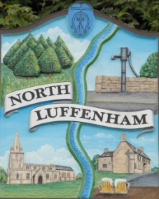
All Councillors are summoned to the Parish Council (Trust) Meeting (virtual) immediately following the Parish Council Meeting on Monday, 19th October 2020.
North Luffenham Parish Council

Agenda

57/20 Apologies:
58/20 Declarations of Interest
59/20 To approve and sign Minutes as follows: Parish Council (Trust) meeting 28th September (virtual)

60/20 Finance Report – Clerk
- To receive a report from Cllr Burrows – Bank Reconciliation
- To receive, consider and approve Finance Report
- To set a date for the Finance Sub Committee to discuss the budget for 2021-22
- To propose and agree the new Mandate for the funds invested with CCLA
- To note the following contractual payments:
- £224.29 Mow All re September
- To receive, consider and approve the following payment
- £293.22 RCC re tree survey

61/20 Field Gardens Report - Cllr Cade
- Allotments
- Woodland Walk

62/20 Oval Report - Cllr Cade

63/20 Date of next meeting: Monday 7th December, immediately following the NLPC meeting (Virtual)

John Willoughby
Parish Clerk
13th October 2020

