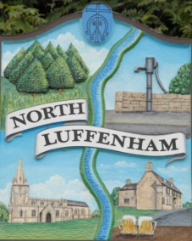
Dates of Meetings for NLPC / Trust meetings as approved
North Luffenham Parish Council

Dates from January 2021 – April 2022

All meetings are full Parish Council Meetings scheduled for Mondays unless stated otherwise below. The meetings usually begin at 7.30pm unless otherwise notified online and on printed Agendas and take place in the Community Centre:

- 25th January 2021
- 22nd February
- 22nd March 2021
- 19th April 2021 (Annual Parish Meeting)
- 17th May 2021 (Annual Parish Council Meeting)
- 21st June 2021
- 19th July 2021
- 16th August 2021
- 20th September 2021
- 18th October 2021
- 22nd November 2021
- 20th December 2021
- 24th January 2022
- 21st February 2022
- 21st March 2022
- 18th April 2022 (Annual Parish Meeting)

