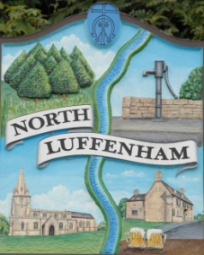
All Councillors are summoned to the Parish Council (Trust) Meeting (virtual) immediately following the Parish Council Meeting on Monday, 7th December 2020.
North Luffenham Parish Council

Agenda

64/20 Apologies:
65/20 Declarations of Interest
66/20 To approve and sign Minutes as follows: Parish Council (Trust) meeting 19th October (virtual)

67/20 Finance Report – Clerk
- To receive a report from Cllr Burrows – Bank Reconciliation
- To receive, consider and approve Finance Report
- To receive, consider and approve the Budget for 2021/2022 as submitted by the Finance Working Group.
- To note the following contractual payments:
- £224.29 Mow All re October
- £315.00 4 Counties re September
- £315.00 4 Counties re October-November
- £26.74 Waterplus re allotment water supply
- To receive, consider and approve the following payments
- £69.99 Charles Cade re daffodil bulbs for Oval
- £480.00 (£400 plus £80 vat) George Walker tree care re work relating to tree report

68/20 Field Gardens Report - Cllr Cade
- Allotments
- Woodland Walk

69/20 Oval Report - Cllr Cade
- The receive and consider the request from the Parochial Church Council to use The Oval for an informal Service with Carols at 6pm on Sunday 20th December. This service will, of course, be strictly in accordance with the Governments Covid Regulations at the time.
The cricket club have been asked permission to use the pavilion.

70/20 Date of next meeting: Monday 25th January, immediately following the NLPC meeting (Virtual)

John Willoughby
Parish Clerk
1st December 2020

