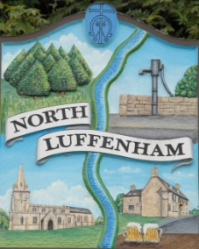
All Councillors are summoned to the Parish Council (Trust) Meeting (virtual) immediately following the Parish Council Meeting on Monday, 25th January 2021.
North Luffenham Parish Council

Agenda

01/20 Apologies:
02/21 Declarations of Interest
03/21 To approve and sign Minutes as follows: Parish Council (Trust) meeting 7TH December (virtual)

04/21 Finance Report – Clerk
- To receive a report from Cllr Burrows – Bank Reconciliation
- To receive, consider and approve Finance Report
- To receive, consider and approve the following payments:
- £160.50 Chris Knott Insurance re Allotment insurance 2021

05/21 Field Gardens Report - Cllr Cade
- Allotments
- Woodland Walk: To consider expenditure up to £50 to purchase bird boxes

06/21 Oval Report - Cllr Cade
- To discuss a tree replacement policy for the Oval in view of potential ongoing costs and liabilities

07/21 Date of next meeting: Monday 22nd February 2021, immediately following the NLPC meeting (Virtual)

John Willoughby
Parish Clerk
19th January 2021

