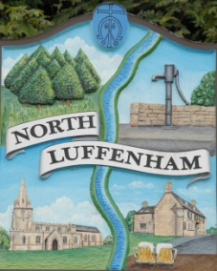
All Councillors are summoned to the Parish Council (Trust) Meeting (virtual) immediately following the Parish Council Meeting on Monday, 22nd February 2021.
North Luffenham Parish Council

Agenda

08/20 Apologies:
09/21 Declarations of Interest
10/21 To approve and sign Minutes as follows: Parish Council (Trust) meeting 25th January 2021 (virtual)

11/21 Finance Report – Clerk
- To receive a report from Cllr Burrows – Bank Reconciliation
- To receive, consider and approve Finance Report
- To receive and consider the letter from CCLA re switching funds from COIF Charities Investment fund to COIF Charities Ethical Investment fund
- To receive, consider and approve the following payments:
- £98.06 Water-plus re water supply to Allotments

12/21 Field Gardens Report - Cllr Cade
- Allotments
- Woodland Walk: To receive and consider the cost of £3252.78 for new fencing and gates for the extension of the woodland walk

13/21 Oval Report - Cllr Cade
- Oval Trees – Update on discussions re replacement strategy

14/21 Date of next meeting: Monday 22nd March 2021, immediately following the NLPC meeting (Virtual)

John Willoughby
Parish Clerk
16th February 2021

