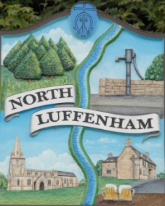
All Councillors are summoned to the Parish Council (Trust) Meeting (virtual) immediately following the Parish Council Meeting on Monday, 29th March 2021.
North Luffenham Parish Council

Agenda

15/21 Apologies:
16/21 Declarations of Interest
17/21 To approve and sign Minutes as follows: Parish Council (Trust) meeting 22nd February (virtual)

18/21 Finance Report – Clerk
- To receive a report from Cllr Burrows – Bank Reconciliation
- To receive, consider and approve Finance Report
- To receive and consider the letter from CCLA re switching funds from COIF Charities Investment fund to COIF Charities Ethical Investment fund
- To receive, consider and approve the following payments:
- £192.00: Wicksteed Leisure re play inspection 2021
- £162.76: Wicksteed Leisure re replacement seat for swing
- £108.00: Wicksteed Leisure re play inspection 2020. (Invoice not originally received

19/21 Field Gardens Report - Cllr Cade
- Allotments: To receive and consider the quotation from G Walker Tree Care ltd to fell 2 cherry trees that are impacting on the bowling club green in the sum of £575 plus VAT and a further £65 plus VAT to treat the stumps with Eco Plugs to prevent re-growth
- Woodland Walk: Update on cost of new fencing

20/21 Oval Report - Cllr Cade
- Oval Trees – Update on discussions re replacement strategy
- To consider and agree expenditure of up to £100 to buy wild flower seeds
- To receive consider and approve the quote of £456 from Trevor Johnson to replace the wooden platform on the multi-play climbing frame. The quote from Wicksteed Leisure was £642 + vat
- To receive and consider a request from a resident of North Luffenham to hold Yoga classes on the Oval.

21/21 Date of next meeting: 19th April 2021 immediately following the NLPC meeting (Virtual)

John Willoughby
Parish Clerk
23rd March 2021

