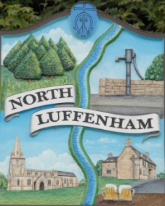
North Luffenham Parish Council

All Councillors are summoned to the Parish Council Extraordinary Meeting (virtual)on Monday 26th April 2021 at 7.30pm

Agenda

The public may attend the meeting but there will be no Public Forum

46/21 Apologies:
47/21 Declarations of Interest
48/21 Chairman’s Report:
- Annual Parish Meeting
- Receipt of CIL Monies – To consider any infrastructure expenditure and the need to consult with the parish re priorities

49/21 Finance Report – Clerk

  - To receive the draft financial report for the financial year 1st April 2020 to 31st March 2021.
  - To receive the draft AGAR report for the year to 31st March 2021
  - To note the receipt of £8944.38 from RCC being a CIL payment re Fir Tree House, Ketton Road.
  - To receive and approve the following contractual payments:
- £210.00; LRALC re Internal Audit Fee
- £40.00; ICO re data protection renewal fee
- £243.69; NALC/LRALC membership fees
- £100.00; DM Payroll. Annual fee
e. To receive, consider and approve the following payments
- £303.49;T Smith re Stamped addressed envelopes for Neighbourhood plan consultation
- £669.64: Refund of NP Grant not spent by 31st March 2021
- £80.12: Speigl Press re printing of newsletter

50/21 To receive, consider and approve the recommended appointment of a new Parish Clerk: Personnel committee

51/21 Community Centre; Update from the management committee
- List of possible expenditure items

52/21 Planning Cllr Burrows
- Glebe Road development

53/21 Highway issues
- Benches update re circular walk
- Speeding along Edith Weston Road
- Glebe Road ( Sharp corners)
- Signage review at PiltonRd/Glebe Road crossroads

54/21 North Luffenham Village Trust: To consider nomiations for Parish Council representation on the NLVT as current nominee term expires at the beginning of May

55/19 Date of next meeting: Annual Parish Council Meeting; Monday 17th May 2021 @7.30pm

John Willoughby
Parish Clerk
20th April 2021

