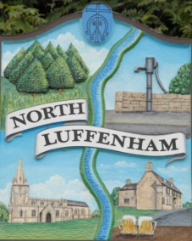
Councillors are summoned to the Parish Council (Trust) Extraordinary Meeting (virtual) immediately following the Parish Council Meeting on Monday 26th April 2021.
North Luffenham Parish Council

Agenda

The public may attend the meeting.

22/21 Apologies
23/21 Declarations of Interest
24/21 Finance Report – Clerk
- To receive, consider and approve the draft Financial report for the financial year 1st April 2020 to 31st March 2021

25/21 Field Gardens Report - Cllr Cade
- Allotments: To consider the request to fell the two cherry trees situated between the bowls club and the allotments.
- Woodland walk: To consider the purchase of a bench (cost £250)
- To receive an update with regard to fencing the additional woodland walk path.

26/21 Oval Report - Cllr Cade
- Schedule weekend clear-up and allocate areas of responsibility.

27/21 Date of next meeting: Monday 17th May 2021 @ 7.30pm

John Willoughby,
Parish Clerk
20th April 2021

