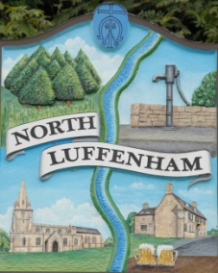
North Luffenham Parish Council

Parish Councillors

Name | Responsibilities | Phone
Mary Canham | - Planning  - Staff Committee | 721721  marycanham@nothluffenham.org.uk
Charles Cade,  Vice-Chairman | Finance Working Group  Oval/Field Gardens Group  - Community Centre  - Play area working group  - Neighbourhood Plan SG | 01780 720467  charlescade@northluffenham.org.uk
Bob Sewell | - Planning Committee  - Staff Committee | 01780 721346  07747 085376  bobmanorfarm@hotmail.co.uk
Tracey Barsby | - Oval/Field Gardens  - Finance Working Group | 07709 646346  traceybarsby@northluffenham.org.uk
Pete Burrows | - Planning Committee  - SGB Working Group  - Web Working Group  - Play area working group  - Neighbourhood Plan SG | 01780 721674  peteburrows@northluffenham.org.uk
Michael Anker | - Finance Working Group  - Planning Committee  - Staff Committee  - SGB Working Group  - Village Trust Appointee | 07776 195958  michaelanker@northluffenham.org.uk
Tim Smith  Chairman | - Neighbourhood Plan SG  - Web Working Group  - Play area working group  - Staffing Committee | 01780 360083  timsmith@northluffenham.org.uk
Martin Marsh | - Planning | 01780 591244  martinmarsh@northluffenham.org.uk
 | Parish Clerk
John Willoughby | nlparishclerk@outlook.com  also  clerk@nortluffenham.org.uk | 01780 408288
County Councillors for the Normanton Ward
Councillor Gale Waller: gwaller@rutland.gov.uk |  | 01780 722169
Councillor Kenneth Bool: kbool@rutland.gov.uk |  | 01572 813356
North Luffenham Village Booklet is handy printed directory containing useful telephone numbers of local services, village clubs and societies.
Online information is also available at: www.northluffenham.com

