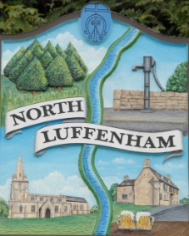
All Councillors are summoned to the Parish Council (Trust) Annual Meeting immediately following the Parish Council Meeting on Monday, 17th May 2021 at North Luffenham Community Centre.
North Luffenham Parish Council

Agenda

28/21 Election of Chair, Vice-Chair
29/21 Apologies:
30/21 Declarations of Interest
31/21 To review and confirm Committees & Working Groups for 2017/18
- Oval/Field Working Group – currently Cllrs Cade, Barsby, Burrows and Smith

32/21 To approve and sign Minutes as follows:
- Parish Council (Trust) meeting of 29th March 2021 (virtual)
- Extraordinary meeting 26th April 2021 (virtual)

33/21 Finance Report – Clerk
- To receive a report from Cllr Burrows – Bank Reconciliation
- To receive, consider and approve Finance Report
- To receive, consider and approve the following payments:
- £224.29 Mow-All April invoice

34/21 Field Gardens Report - Cllr Cade
- Allotments
- Woodland Walk:

35/21 Oval Report - Cllr Cade

36/21 Date of next meeting: Monday, 21st June 2021, immediately following the NLPC meeting

John Willoughby
Parish Clerk
10th May 2021

