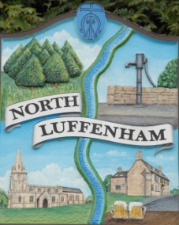
North Luffenham Parish Council

All Councillors are summoned to the Parish Council Extraordinary Meeting on Monday 14TH June 2021 at 7.30pm at North Luffenham Community Centre

Agenda

This is a closed meeting

75/21 Apologies:
76/21 Declarations of Interest
77/21 NLVT nomination
- Letter from NLVT
- Verbal report from Staffing Committee

78/21 Date of next meeting: Monday 21st June 2021 @7.30pm

Barry Read
Parish Clerk
8th June 2021

