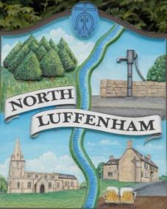
The Councillors are summoned to a Parish Council (Trust) Meeting on Monday, 19th July 2021 at North Luffenham Community Centre.
North Luffenham Parish Council

Agenda

The public may attend the meeting

44/21 Apologies:
45/21 Declarations of Interest:
46/21 The public Forum

47/21 To approve and sign Minutes as follows:

- Parish Council (Trust) meeting of 21st June 2021

48/21 Finance Report – Clerk
- To receive a report from Cllr Burrows – Bank Reconciliation
- To receive, consider and approve Finance Report
- To receive, consider and approve the following payments:
- £315.00 Counties Ground
- £224.29 Mow-All June invoice

49/21 Field Gardens Report - Cllr Cade
- Allotments
- Woodland Walk:

50/21 Oval Report - Cllr Cade

51/21 Date of next meeting: Monday 16th August 2021, immediately following the NLPC meeting.

Barry Read
Parish Clerk
15th June 2021

