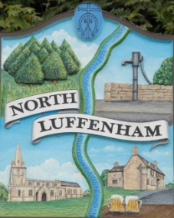
Minutes of the Parish Council (Trust) Meeting on Monday, 21st June 2021 at North Luffenham Community Centre.
North Luffenham Parish Council

37/21 Apologies: Cllr Marsh
38/21 Declarations of Interest: None

39/21 To approve and sign Minutes as follows:
- Parish Council (Trust) meeting of 17th May 2021 (virtual)

40/21 Finance Report – Clerk
- To receive a report from Cllr Burrows – Bank Reconciliation
- To receive, consider and approve Finance Report
- To receive, consider and approve the following payments:
- £224.29 Mow-All May invoice

41/21 Field Gardens Report - Cllr Cade
- Allotments
- Woodland Walk:

42/21 Oval Report - Cllr Cade

43/21 Date of next meeting: Monday, 19th July 2021, immediately following the NLPC meeting

Barry Read
Parish Clerk
21st June 2021

