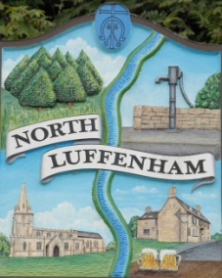
Dates of Meetings for NLPC / Trust meetings as approved
North Luffenham Parish Council

Dates from May 2022 – April 2023

All meetings are full Parish Council Meetings scheduled for Mondays unless stated otherwise below. The meetings usually begin at 7.30pm unless otherwise notified online and on printed Agendas and take place in the North Luffenham Community Centre:

- 16th May 2022 (Annual Parish Council Meeting)
- 20th June 2022
- 18th July 2022
- 15th August 2022
- 19th September 2022
- 17th October 2022
- 21st November 2022
- 19th December 2022
- 16th January 2023
- 20th February 2023
- 20th March 2023
- 3rd April 2023 (Annual Parish Meeting

