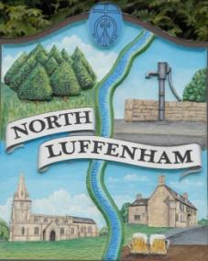
All Councillors are summoned to the Parish Council Meeting on Monday, 21st February 2022 at 7.30pm @ NL Community Centre
North Luffenham Parish Council

Agenda

23/22 Apologies:
24/22 Declarations of Interest
25/22 Public Forum

26/22 To approve and sign Minutes as follows:
- Parish Council meeting of 24th January 2022

27/22 Ward Report

28/22 Chairman’s Report

- RCC Local Plan
- Co-option of Cllr
- Parish Clerk

29/22 Correspondence – Clerk

- RCC Call for sites re Local Plan
- RCC weekly roundup
- Email re Trees maintenance on Oval

30/22 Finance Report – Clerk
- To receive a report from Cllr Burrows – Bank Reconciliation
- To receive consider and approve the Finance Report
- LRALC Payrole services from April 2022 Cost £65 pa Expression of Interest submitted.
- To note a VAT claim of £1121.22 for period 01/08/21 to 31/01/22
- To approve the following payments:
RCC Lighting £660.13
B Read salary £1316.88
Groundworks re bench bases ££1944.00

31/22 Planning - Cllr Burrows

T2022/0134/FUL PROPOSAL: Change of use of agricultural land to proposed expansion car park. Luffenham Heath Golf Club Stamford Road South Luffenham Rutland PE9 3UU

Decision Notice 2021/1040/FUL PROPOSAL: Construction of a replacement dwelling and demolition of existing bungalow LOCATION: The Bungalow, Ketton Road North Luffenham Rutland PE9 3UT: GRANT PLANNING PERMISSION in accordance with the application and plans submitted

31/22 Update report from Neighbourhood Planning Steering Group

32/22 To receive and consider the report from the Community Centre Management Committee

33/22 SGB Solar Farm proposal

34/22 Queen’s Jubilee Celebrations

35/22 To consider meeting dates 2022/23

36/22 To agree a revised date for this year’s Annual Parish Meeting

37/22 Date of next Parish Council meeting, Monday 21st March 7.30pm

John Willoughby
Parish Clerk
14th February 2022

