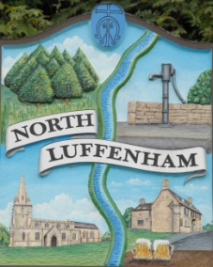
All Councillors are summoned to the Parish Council (Trust) Meeting immediately following the Parish Council Meeting on Monday, 21st February 2022
North Luffenham Parish Council

Agenda

08/22 Apologies:
09/22 Declarations of Interest
10/22 To approve and sign Minutes as follows: Parish Council (Trust) meeting 24th January 2022

11/22 Finance Report – Clerk
- To receive a report from Cllr Burrows – Bank Reconciliation
- To receive, consider and approve Finance Report
- To receive, consider and approve the following payments:
- £768.00 G Walker Tree Care re 2 Cherry Trees
- £212.80 RCC re tree inspection
- £200.00 Age UK re bench for Oval

12/22 Field Gardens Report - Cllr Cade
- Allotments
- Woodland Walk: update to fencing

13/22 Oval Report - Cllr Cade
- Oval Trees – Update on discussions re replacement strategy

14/21 Date of next meeting: Monday 21st March 2022, immediately following the NLPC meeting (Virtual)

John Willoughby
Parish Clerk
14th February 2022

