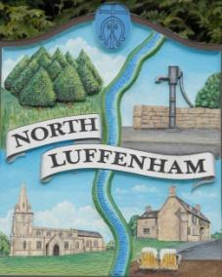
North Luffenham Parish Council

All Councillors are summoned to the Parish Council Extraordinary Meeting on 10th March 2022 at 7.30pm

Agenda

The public may attend the meeting but there will be no Public Forum

38/22 Apologies:
39/22 Declarations of Interest
40/22 Chairman's report
41/22 To receive, discuss and consider a proposal to fund the parish Jubilee Celebrations up to £1000 in accordance with budget

42/22 To receive, discuss and consider the proposed neighbourhood plan policies for North Luffenham prior to submission to RCC for screening

43/22 To seek permission to close the meeting to the public to consider agenda item 44/22

44/22 To receive, discuss and consider a formal complaint from a resident of North Luffenham

John Willoughby
Parish Clerk
5th March 2022

