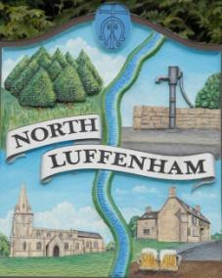
All Councillors are summoned to the Parish Council Meeting on Monday, 21st March 2022 at 7.30pm @ NL Community Centre
North Luffenham Parish Council

Agenda

38/22 Apologies:
39/22 Declarations of Interest
40/22 Public Forum

41/22 To approve and sign Minutes as follows:
- Parish Council meeting of 21st February 2022
- PC Extraordinary Meeting held on 10th March 2022

42/22 Ward Report

43/22 Chairman’s Report

- RCC Local Plan
- Co-option of Cllr

44/22 Correspondence – Clerk

- RCC weekly roundup
- Email from resident re street lighting issues in the village

45/22 Finance Report – Clerk
- To receive a report from Cllr Burrows – Bank Reconciliation
- To receive consider and approve the Finance Report
- To consider and approve the following payments:
- £22.07 Ionos re website hosting
- £1028.50: Clerk salary
- £105.60 re defibrillator

46/22 Planning - Cllr Burrows

Reference: 2022/0184/FUL
PROPOSAL: Single storey side garden room extension and erection of a greenhouse.
12 Glebe Road North Luffenham Oakham Rutland LE15 8JU

Reference: 2022/0307/CAT
The Town & Country Planning (Tree Preservation) (England) Regulations 2012 PROPOSAL: Remove branches overhanging 3 Pinfold Lane Case Officer Tel: Garages And Land Pinfold Close North Luffenham Rutland

47/22 Update report from Neighbourhood Planning Steering Group

48/22 To receive and consider the report from the Community Centre Management Committee

49/22 SGB Solar Farm proposal and update

50/22 Queen’s Jubilee Celebrations
- To receive an update on the planning of events
- To write to the PC Trust for use of the Oval for the Jubilee Celebrations

51/22 To receive, discuss and consider the street lighting issues raised by a North Luffenham resident

52/22 To seek permission to close the meeting to the public to consider agenda item 53/22

53/22 To receive, discuss and consider a formal complaint from a resident of North Luffenham

54/22 Date of next Parish Council meeting, Monday 16th May 7.30pm (Annual Parish Council Meeting)

John Willoughby
Parish Clerk
14th March 2022

