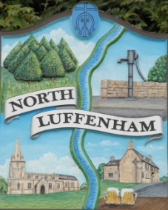
All Councillors are summoned to the Parish Council (Trust) Meeting immediately following the Parish Council Meeting on Monday, 21st March 2022
North Luffenham Parish Council

Agenda

15/22 Apologies:
16/22 Declarations of Interest
17/22 To approve and sign Minutes as follows: Parish Council (Trust) meeting 21st February 2022

18/22 Finance Report – Clerk
- To receive a report from Cllr Burrows – Bank Reconciliation
- To receive, consider and approve Finance Report

19/22 Field Gardens Report - Cllr Cade
Allotments:
- To receive, discuss and consider increasing the number of allotment plots to the upper allotment area
- To receive an update on current availability of any vacant plots

Woodland Walk: To consider any revised quotes received to install new fencing to the revised route

20/22 Oval Report - Cllr Cade
- Oval Trees – Update on discussions regarding removing broken branches from trees and also disposal/shredding of branches from the Oval
- To receive and consider the request from the PC to use the Oval for some of the Jubilee Celebrations

14/21 Date of next meeting: Monday 16th May 2022, immediately following the NL Annual PC meeting (Virtual)

John Willoughby
Parish Clerk
14th March 2022

