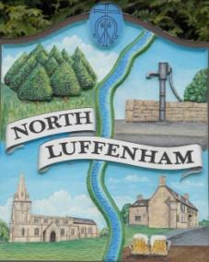
North Luffenham Parish Council

All Councillors are summoned to the Parish Council Extraordinary Meeting on 4th April 2022 at 7.30pm @ North Luffenham Community Centre

Agenda

This will be a closed meeting

55/22 Apologies:
56/22 Declarations of Interest
57/22 Chairman's report
- Clerk appointment
58/22 Co-option of a new Parish Cllr: To receive and consider the candidates who had expressed an interest in being a Parish Cllr and make a decision as to who to co-opt.

59/22 To receive, consider and approve the draft Finance report for the year ending 31st March 2022

60/22 Date of next meeting: 16th May 2022; Annual Parish Council meeting

John Willoughby
Parish Clerk
27th April 2022

