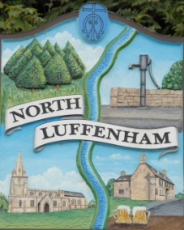
All Councillors are summoned to the Parish Council (Trust) Annual Meeting immediately following the Annual Parish Council Meeting on Monday, 16th May 2022 at North Luffenham Community Centre.
North Luffenham Parish Council

Agenda

15/221 Election of Chair, Vice-Chair
16/22 Apologies:
17/22 Declarations of Interest
18/22 To review and confirm Committees & Working Groups for 2022/23
- Oval/Field Working Group – currently Cllrs Cade, Barsby, Burrows and Smith

19/22 To approve and sign Minutes as follows:
- Parish Council (Trust) meeting of 21st March 2022

20/22 Finance Report – Clerk
- To receive a report from Cllr Burrows – Bank Reconciliation
- To receive, consider and approve Finance Report for the year ending 31st March 2022
- To receive, consider and approve the following payments:
- £229.29; Mow All April cut
- £315.00; 4 Counties April cuts

21/22 Field Gardens Report - Cllr Cade
- Allotments
- Woodland Walk:

23/22 Oval Report - Cllr Cade
- Cricket square mowing

24/22 Date of next meeting: Monday, 20th June 2022, immediately following the NLPC meeting

John Willoughby
Parish Clerk
9th May 2022

