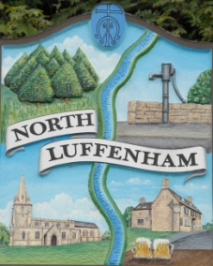
All Councillors are summoned to the Parish Council (Trust) Meeting immediately following the Parish Council Meeting on Monday, 20th June 2022
North Luffenham Parish Council

Agenda

25/22 Apologies: Tim Smith
26/22 Declarations of Interest
27/22 To approve and sign Minutes as follows: Parish Council (Trust) meeting 16th May 2022

28/22 Finance Report – Clerk
- To receive a report from Cllr Burrows – Bank Reconciliation
- To receive, consider and approve Finance Report
- To approve the following contractual payments:
- £535.00; 4 Counties re grass cutting of Oval (May) and Woodland walk
- £229.29; Mow All May

29/22 Field Gardens Report - Cllr Cade
Allotments:
- To receive an update on current availability of any vacant plots
- Update on position re additional allotments

Woodland Walk:
- Spraying of crops in the adjacent fields
- New fencing update

30/22 Oval Report - Cllr Cade
- Play equipment repairs
- Compost area/bin for grass cuttings
- Update re leases for Cricket and Bowls Clubs

31/21 Date of next meeting: Monday 18th July 2022, immediately following the NLPC meeting (Virtual)

John Willoughby
Parish Clerk
14th June 2022

