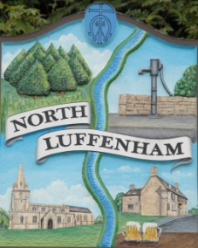
All Councillors are summoned to the Parish Council (Trust) Meeting immediately following the Parish Council Meeting on Monday, 18th July 2022
North Luffenham Parish Council

Agenda

32/22 Apologies
33/22 Declarations of Interest
34/22 To approve and sign Minutes as follows:

- Parish Council (Trust) meeting of 20th June.

35/22 Finance Report – Clerk

- To receive a report from Cllr Burrows – Bank Reconciliation
- To receive, consider and approve Finance Report
- To note receipt of payment £369 from Sewell & son for agricultural tenancy
- To note the following contractual payments:
- £229.29 re Mow all June
- £315 re 4 Counties

36/22 Field Gardens Report - Cllr Cade

Allotments:

- To receive an update on current availability of any vacant plots
- Update on position re additional allotments

Woodland Walk:

- New fencing update

37/22 Oval Report - Cllr Cade

38/22 Date of next meeting: Monday 15th August 2022,
immediately following the NLPC meeting

Sue Hammond
Parish Clerk
14th June 2022

