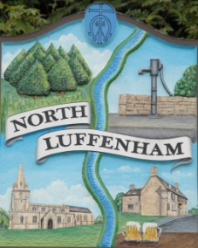
Minutes of the Parish Council (Trust) Meeting held on Monday 15th August
North Luffenham Parish Council

Present: Cllrs. Smith, Burrows, Gore, Barsby, Cade

39/22 Apologies: Cllr Canham

40/22 Declarations of Interest: None
41/22 The minutes of the Trust meetings of 20th June and 18th July were approved and signed by the Chair.

42/22 Finance Report – Clerk

- The bank reconciliation was deferred to allow Cllr Barsby to meet with the Clerk separately.
- The following contractual payments were duly noted:-

  - £229.29, Mow All July and
  - £62.89 Waterplus for the allotment.

£1092.24 paid to Wicksteeds for ramp repair was noted along with the need to transfer into the Community Account to cover continued outgoings. (£2,000 from Business Money manager account)

43/22 Field Gardens Report

Allotments

- To receive an update on the current availability of any vacant plots.
- Update on position re additional allotments.

Cllr Cade explained that there was one vacant plot available at the present time, with no takers yet. He went on to set out the options involved in supplying additional allotments and proposed that the council look at providing up to three acres for additional allotments, while also considering allocating some space for woodland. Cllr Barsby seconded this with all in favour. Cllr Cade to report back on this.

Woodland Walk

- New fencing update

Cllr Cade is following up with the fencing contractor.

44/22 Oval Report

While it is currently too hot to contemplate grass-cutting, the council discussed the options for increasing the number of flowers in the immediate area.

45/22 Date of next meeting: Monday 19th September 2022,
immediately following the NLPC meeting

The meeting closed at 9.26pm.

Sue Hammond
Parish Clerk

