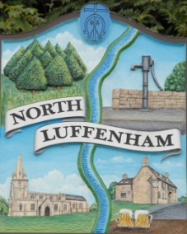
All Councillors are summoned to the Parish Council (Trust) Meeting immediately following the Parish Council Meeting on Monday, 21st November
North Luffenham Parish Council

Agenda
54/22 Accepted apologies [and future membership of the Trust]
55/22 Declarations of Interest
56/22 To approve and sign Minutes of the Parish Council Trust meeting of 17th October 2022.
57/22 Correspondence
Letter from the Charity Commission publicising Trustees’ week
58/22 Finance Report – Clerk
- Report provided till end of October 22.
Also to note:-
- Payment received £369 from Sewell & son for agricultural tenancy
- And to note contractual payments

Mowall £229.29
RCC for Tree inspection £142.50
Waterplus £284.19 for 23/9/22 – 23/10/22

59/22 Field Gardens Report - Cllr Cade
Allotments: …
- To receive an update on current availability of any vacant plots
- Update on position re additional allotments

Woodland Walk:..
60/22 Oval Report - Cllr Cade…
61/22 Date of next meeting: Monday 19th December 2022,
immediately following the NLPC meeting

Sue Hammond, Parish Clerk
15th November 2022

