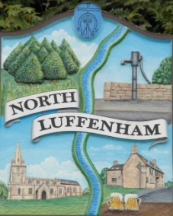
Minutes of the Parish Council (Trust) Meeting held on Monday 17 October 2022
North Luffenham Parish Council

Present: Cllrs. Marsh, Smith, Burrows, Canham and Cade

46/22 Acceptance of apologies for absence: Cllrs Gorse and Barsby

47/22 Declarations of Interest:
Cllrs Burrows and Cade declared membership of the Cricket Club
48/22 To approve and sign minutes

The minutes of the Trust meetings of 15th August 2022 were agreed and signed with the addition of Cllr Marsh’s name to the Apologies.

49/22 Bonfire Night

It was agreed that the Field Garden Trust would allow the Parish Council to use the Oval Recreation Ground to celebrate Bonfire Night on Saturday 5 November this year.

50 /22 Finance Report – Clerk

- The following contractual payments were duly noted:-

  - £229.29, Mow All for August and September, £535 to Counties Grounds Maintenance and £26.46 to Waterplus. The Waterplus bill marked a transition to monthly billing.
  - The full Financial Report was deferred to allow the Clerk to take further advice.

51/22 Field Gardens Report

Allotments

- To receive an update on the current availability of any vacant plots.
- Update on position re additional allotments.

Cllr Cade explained that there were two vacant plots currently available but a decision on those would be left to the end of the year. The potential for new allotments was discussed but bearing in mind the likely cost of £4,000 to £5,000 for fencing alone, he would bring a full costing to the next meeting for further consideration.

Woodland Walk

- New fencing update: It was agreed that the current contractor be asked to commit to a date for the work, or the council would be obliged to consider a retender process.

52/22 Oval Report

- Cllr Cade said he was waiting for a report on one tree and confirmed that he would arrange for a suitable company to take down dead branches from trees across the Oval.
- Ketton PC have offered the parish some additional trees, with a view to planting them on the Oval. It was agreed to support this, with a view to focusing on native species and the need to encourage wildlife

Bowls and Cricket Club Leases

Cllr Canham agreed to put together heads of terms to renew both leases. The ownership of the buildings on both parcels of land was discussed, and she will look at this in more detail.

53/22 Date of next meeting: Monday 21 November 2022
immediately following the NLPC meeting

The meeting closed at 9.54pm.

Sue Hammond
Parish Clerk

