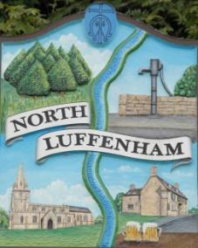
All Councillors are summoned to the Parish Council Meeting on Monday, 16th of January 2023 at 19:30 - NL Community Centre.
North Luffenham Parish Council

Agenda

08/23 Apologies

09/23 Declarations of Interest

10/23 Public Forum

11/23 To approve and sign Minutes as follows:

- Parish Council meetings of 19-12-22 and 12-01-23

12/23 Ward Report

13/23 Chairman’s Report

14/23 Correspondence

15/23 Finance Report:
- To receive, consider and approve the Finance Report:
- To approve the following payments:
- Clerk’s Salary – TBC*
- Zen – £52.13
- Ionos - £5

16/23 Planning - Cllr Burrows

17/23 Neighbourhood Planning Steering Group and to propose the:
- Approval of the submission Neighbourhood Plan

18/23 To receive and consider the report from the Community Centre Management Committee – Cllr Cade

19/23 To receive and consider the report from the CIL Group – Cllr Burrows

20/23 Date of next Parish Council meeting: Monday 20th of February 2023
*Clerks salary is due to be discussed at the meeting on the 12th of January – after this agenda is produced.

Jadene Bale, Parish Clerk

