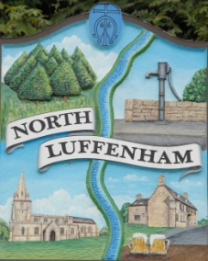
All Councillors are summoned to the Parish Council (Trust) Meeting immediately following the Parish Council Meeting on
North Luffenham Parish Council
Monday, 16th of January 2023 at 19:30 – NL Community Centre.

Agenda

01/23 Acceptance of apologies for absence
02/23 Declarations of Interest
03/23 To approve and sign Minutes:

Parish Council (Trust) meeting 19th of December 2022

04/23 Correspondence

05/23 Finance Report

- To receive, consider and approve the Finance Report:
- To approve the following payments:
- 1&1 Internet Ltd -£6
- 1&1 Internet Ltd - £21.72

06/23 Field Gardens Report - Cllr Cade

Allotments:

- To receive an update on current availability of any vacant plots

Woodland Walk:

- New fencing update

07/23 Oval Report - Cllr Cade

08/23 Date of next meeting: Monday 20th of February 2023
immediately following the NLPC meeting

Jadene Bale, Parish Clerk

