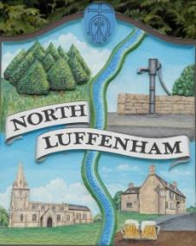
North Luffenham Parish Council
There will be a meeting of the Community Centre Committee in the School Hub on 23rd January at 5.00pm.

Agenda
01/23 Apologies
02/23 Declarations of Interest
03/23 Minutes of the meeting 23-11-22 to be approved.
04/23 Shared Costs: Discussion with School
05/23 Finance Report
06/23 Hallmaster Booking System
07/23 Booking Charges
08/23 Lease
08/23 Date of next meeting

Charles Cade
Chair CCC.17-01-23

