North Luffenham Parish Council

Neighbourhood Plan

Supporting Document No. 1

Local Green Space

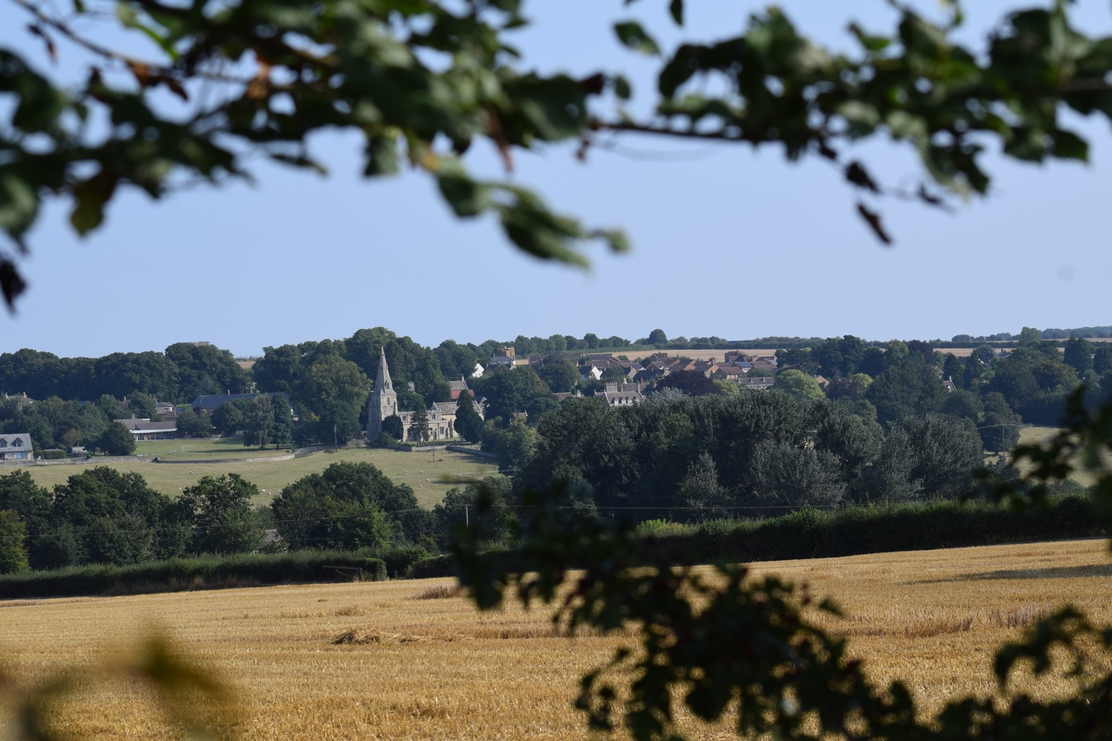

January 2023

North Luffenham: Local Green Space Designation

What are the benefits of designating Local Green Spaces?
Local Green Space designation is a way to provide special protection against development for green areas that are of particular importance to local communities. Designated local green spaces are afforded the same level of protection as green belts, ruling out development in all but very exceptional circumstances. Any type of green space could be suitable for designation and may include land where sports pavilions are located, allotments or urban spaces that provide a tranquil oasis.
Why are our local green spaces important?

Protecting our green spaces is important because they provide: -
- places for relaxation, social interaction as well as venues for events and large gatherings
- green connections between multiple spaces across the parish and away from the highway
- habitats for wildlife and green corridors that contribute to local biodiversity
- places for local residents to grow their own food
- space for the provision of sports and recreational facilities from cricket pitches to children’s playgrounds
- pleasant outlooks for neighbouring properties and enhancement of the visual amenity of the village including settings for historic buildings and landmarks
- spaces for carbon capture by trees and plants which has beneficial impact on climate change
- flood mitigation in some circumstances.

In short, local green spaces contribute to the quality and visual impact of our Parish in the same way as buildings and infrastructure and help make it an attractive place to live, work and play. They add real value to the Parish and have a positive impact on the quality of life of local residents.

Sustainable Development

Neighbourhood Plans must contribute to sustainable development in the area they cover. In the case of green spaces, this means ensuring that the social, economic and environmental benefits of green spaces outlined above have a positive impact on sustainable development. As a consequence, the impact of new developments on existing green spaces and the provision of new green spaces as part of any development form an important factor in determining whether development is sustainable.

The Assessment Approach

Having identified the local green spaces that are of high value to the local community and environment in the main Neighbourhood Plan, this supporting document provides more detail on those sites in order that they can be protected under Local Green Space designation. Our approach to the assessments is in accordance with the guidance and criteria contained in the National Planning Policy Framework (NPPF) 2021 (Paragraphs 101 and 102) to ensure that each site is:
- in reasonably close proximity to the community it serves
- demonstrably special to a local community and holds a particular local significance, for example, because of its:
    - beauty
    - historic significance
    - recreational value (including as a playing field)
    - tranquility
    - richness of wildlife
- local in character and is not an extensive tract of land.

Although the NPPF does not define what qualifies as ‘close proximity’ or an ‘extensive tract of land’, Natural England’s Accessible Greenspace Standards provides a helpful guide. It suggests that ‘close proximity’ should be defined as being within 2km (1.25 miles) of the local community and that an ‘extensive tract of land’ be defined as being over 20 hectares (50 acres). We have taken these guidelines into account when assessing sites for North Luffenham.

Local Consultation

A public consultation on the Local Green Space Assessment was conducted during November and December 2021 including three “drop-in” sessions at the Village Community Centre. Respondees comments were submitted either via the Parish Council website, in person at the Community Centre or by email. The responses and comments received have been analysed and taken into acccount in amending the Local Green Space document for Regulation 14 Neighbourhood Plan consultation in August and September 2022.

Following consideration of consultation responses received, the number of Local Green Spaces originally planned was substantially reduced. This was due to the fact that the NLPC considered that the restrictions imposed by the designation would be overly restrictive in some cases or that they duplicated existing protections.

The Local Green Space is a crucial component aimed at protecting Noth Luffehham’s valued green spaces and should be read in conjunction with Policy NL10: Landscape Setting and Separation in the Neighbourhood Plan.

Local Green Spaces in North Luffenham

Two sites have been identified as being highly valued by the residents of North Luffenham, both are illustrated on the map overleaf (Figure 1). The reference numbers relate to a specific designations each of which is described in the paragraphs which follow.

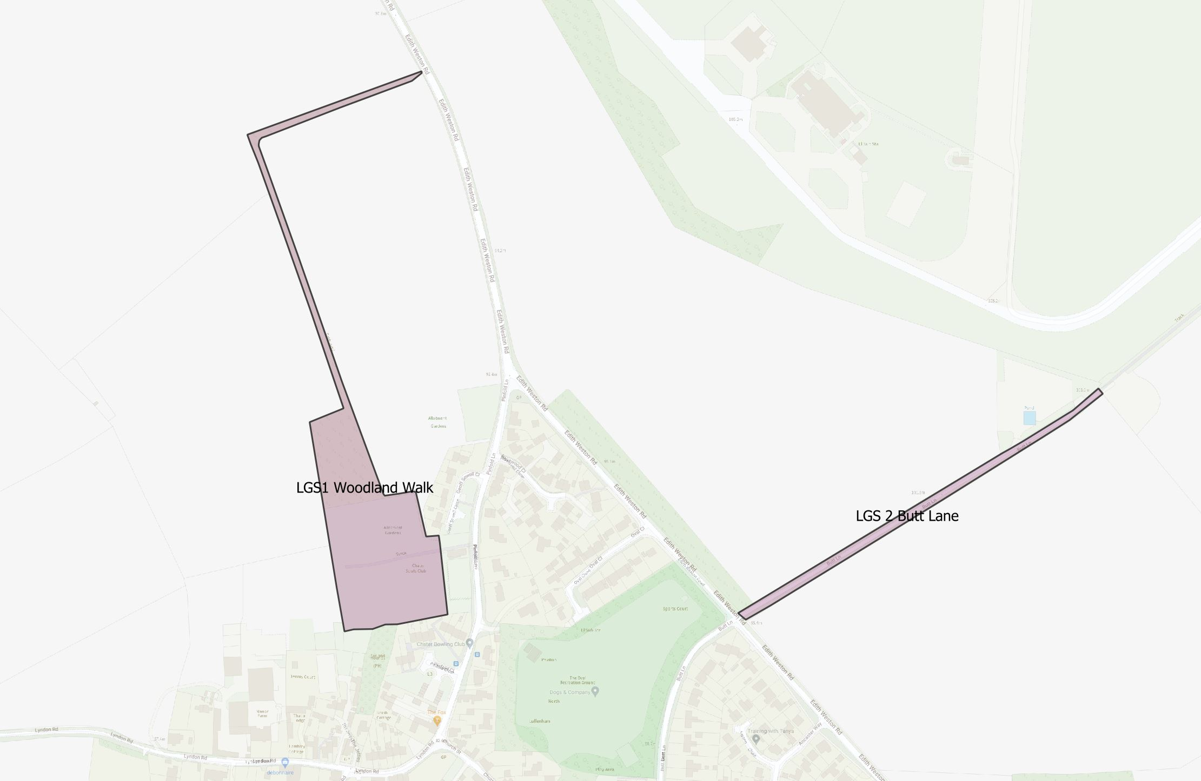© Crown copyright and database rights 2020 OS 0100057736 and Google Maps
Figure 1 - North Luffenham’s Local Green Spaces (LGS 1, 2)

- The Field Garden Woodland, Woodland Walk and Allotments (LGS 1)
The short Woodland Walk has two points of pedestrian access: one via Pinfold Lane and the other via a gate leading off Edith Weston Road. Starting from the Field Garden Woodland, the walk follows the western and northern most boundary of the field (owned by North Luffenham Parish Trust) before joining the Edith Weston Road. Walkers are then able to to return to the village, or continue towards Edith Weston via the footway adjacent to the Road.
The woodland (also owned by North Luffenham Parish Trust) is situated adjacent to the allotments, providing habitat for wildlife and a peaceful place to walk, sit and enjoy the views of the village and wider parish down towards the medieval moat (described in the section on Historic Environment). It should be noted that the Field Gardens Walk is a permissive footpath created by the Parish Council and used by the public in order to enjoy the benefits of the Field Garden and adjoining Village Trust land.
The allotments are owned and managed by the Parish Council and are officially known as the Field Garden Allotments. They comprise two distinct areas of land, both accessed from Pinfold Lane. At the time of writing, the allotments are currently fully utilised and with national trends moving towards growing your own fruit and vegetables the demand for such plots is likely to increase in the future. It is considered essential that the area, whilst designated as an allotment, is protected from development to secure its for future generations.

The land itself was transferred to the Church Wardens of the Parish by the Enclosure Act 1881 (formerly known as the Inclosure Act) with responsibility passing to the Parish Council on its creation in the late 1890s. It was transferred for the purpose of “an allotment for field gardens” which remain the predominant activities for the allotments and the walk and woodland to this day. It is worth noting that the majority of allotments in the UK were designated after the First World War however those located in the parish are unusual as their use for this purpose stretches back over 140 years.
The Field Garden Walk, Woodland and allotments are indiacted by the brown and pink shaded areas on the map in Figure 2.

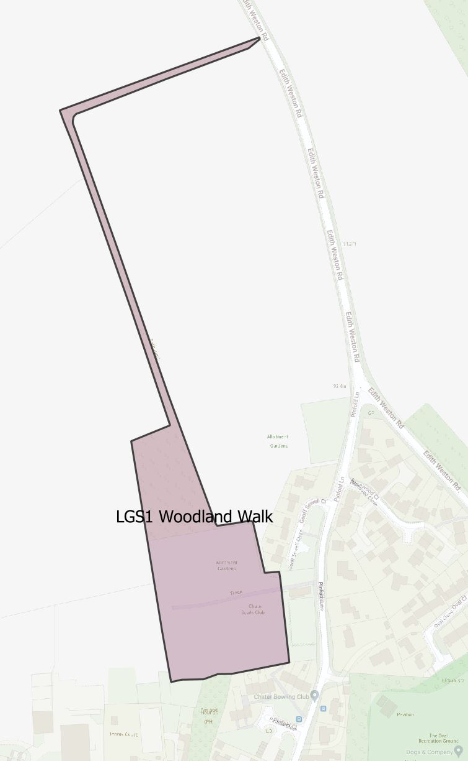
© Crown copyright and database rights 2020 OS 0100057736 and Google Maps
Figure 2: Map Showing the the extent of LGS 1

The Allotments:
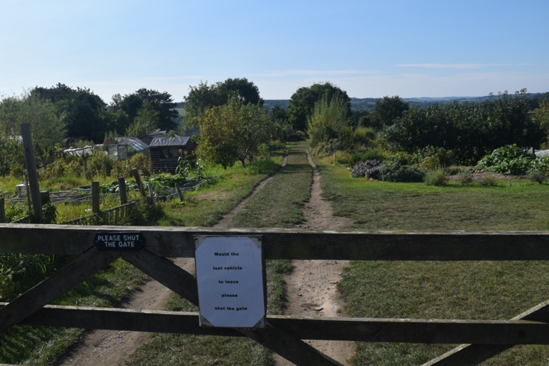
Figure 3: View of the allotments from the entrance.

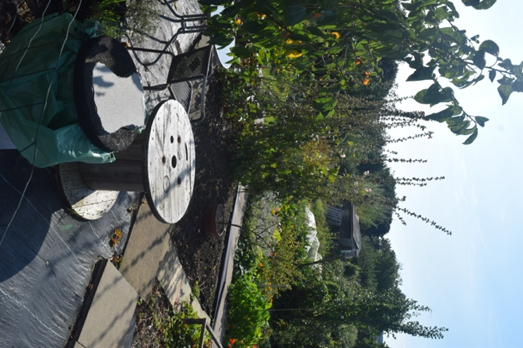

Figure 4: Internal view of the allotments.

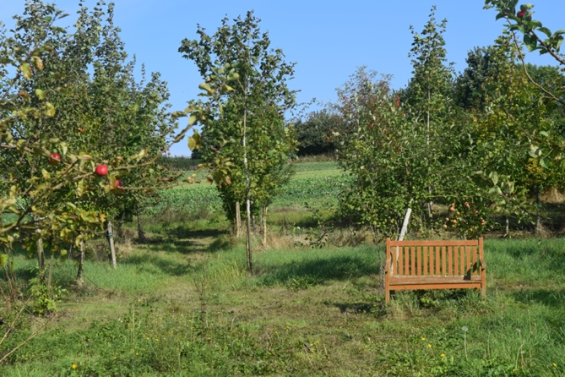
The Field Garden Woodland Walk and Woodland:
Figure 5: Seating area in The Woodland.

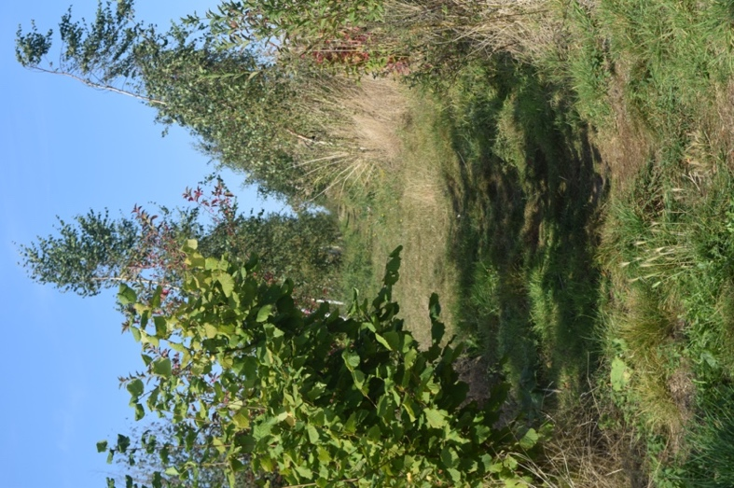

Figure 6: View of the Woodland Walk looking North from the Woodland.

LGS1: The Field Gardens Woodland Walk, Woodland and Allotments
NPPF Criteria | Assessment
Proximity to the community | In the heart of the village.
Demonstrably special to a local community and holds a particular local significance, for example, because of its beauty, historic significance, recreational value (including as a playing field), tranquility and the richness of its wildlife | Easily reached on foot by local residents.  Newly established woodland in a rural parish that has relatively few woods. It is considered excellent for dog walking - many use it for this purpose, daily.  Wildlife habitats have been created in the Fields Garden Woodland for the declining bird population including nest boxes for owls and other birds. It provides feeding grounds for birds and other wildlife in the adjacent grasses and trees.  The allotments have valued views sloping down towards the south and west side of the parish, and the medieval moat.  LGS Consultation responses: 88% “highly approve” and 10% “approve” of the designation of LGS1.
Local in character and is not an extensive tract of land | Appropriate in its size, given its purpose, as demonstrated in the map.

- Butt Lane (North East of Edith Weston Road) (LGS 2)

Butt Lane, from the junction of Edith Weston Road, joining with the section of land designated as a nature corridor that leads up to the parish boundary to meet with the section of land to be protected by the neighbouring parish, Edith Weston. Whilst not currently included on the definitive map the status of the bridleway is not currently known but it has been accessed by local residents, without let or hindrance, over many decades.
This area of North Luffenham, accessed via Butt Lane on the east side of Edith Weston Road, is currently used by residents, fulfilling a need for more general walking, rambling and dog walking. This former public footpath was in use prior to the existence of SGB as a military base but was closed during World War II. The map below shows the boundary of the section not belonging to St. George’s Barracks (MoD), but adjoining it, and has been a valued place to walk and appreciate the tranquility, natural aspects and local vistas for many years. With much of the disused airfield having been used by local residents over the last decade, it is important that the green spaces within the disused airfield should connect with existing green spaces around Butt Lane.
Strong opinions have been expressed, particularly by dog walkers, that without this facility there would be a large gap in the opportunity for residents to walk and allow their dogs off their leads without having to drive to more distant locations. All other fields close to the village are either farmed or used for other purposes. The Oval recreational field, as the only other alternative, is a multi-use facility located in the village itself. In addition, such local routes are relied upon by residents who do not have access to a vehicle. The Parish Council is also committed to reducing the need to travel wherever possible in order to reduce the parish’s Carbon footprint.
It is of great importance to the community for the section adjacent to the south eastern edge of St. George’s Barracks land within North Luffenham parish to be protected for walking and as a significant area of natural beauty with local views. The photograph at Figure 8 is taken from Edith Weston Road looking towards the disused airfield.

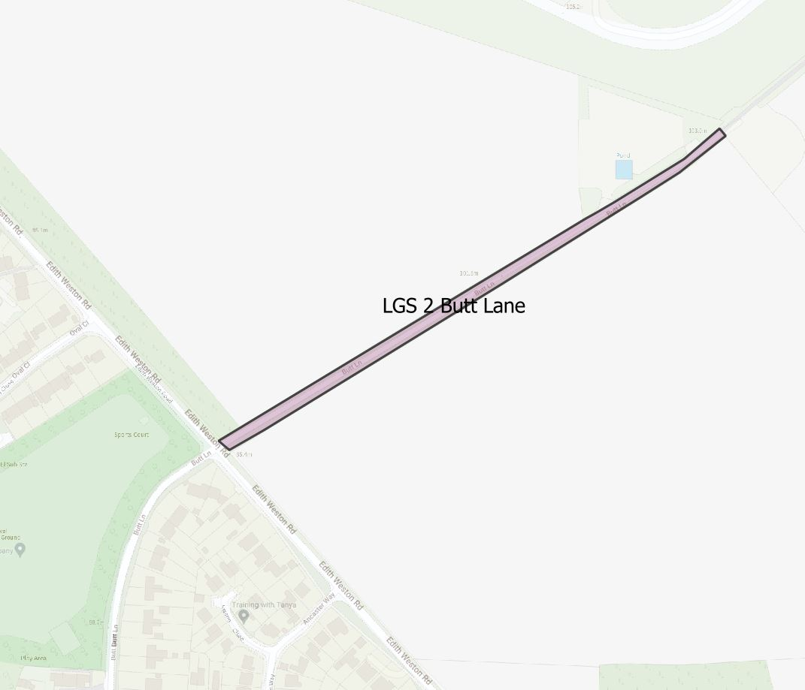
© Crown copyright and database rights 2020 OS 0100057736 and Google Maps
Figure 7: LGS 2 - Butt Lane (North East of Edith Weston Weson Road

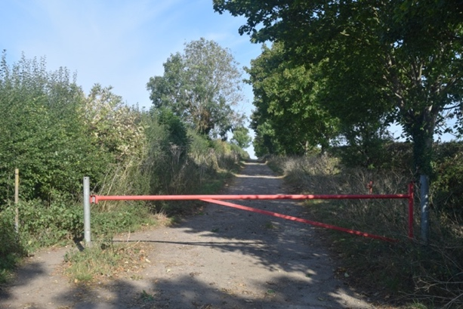

Figure 8: View of Butt Lane from Edith Weston Road.
LGS2: Butt Lane, from the junction of Edith Weston Road, and the section of land, up to the St. Georges boundary.
NPPF Criteria | Assessment
Proximity to the community | Close to the village residential area and the Oval receational open space.
Demonstrably special to a local community and holds a particular local significance, for example, because of its beauty, historic significance, recreational value (including as a playing field), tranquility and the richness of its wildlife | Highly valued by the village community. Connects the village to the local countryside adding to the vistas, tranquility and beauty of these locations.  The public footpath along Butt Lane opens into green space that offers one of the highest and far-reaching panoramic views in the parish.  An area of significant natural beauty and tranquility, with traditional rural aspects. It also has significant heritage value through its association with the Thor Missile Site.  A valued walk from the village where very few alternatives are reachable on foot. It provides opportunities for residents to allow their dogs to run free.  Historic in its existence as a public right of way preceding the use of the land for military purposes.  LGS Consultation responses: 86% “highly approve”and 8% “approve” of the designation of LGS3.
Local in character and is not an extensive tract of land | By its very nature, this is one of the best routes from which to enjoy the local character of the parish. It is not extensive in terms of land mass.

-= END =-

