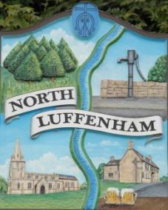
All Councillors are summoned to the Parish Council Meeting on Monday, 20th of February 2023 at 19:30 - NL Community Centre.
North Luffenham Parish Council

Agenda

21/23 Apologies

22/23 Declarations of Interest

23/23 Public Forum

24/23 To approve and sign Minutes as follows:

- Parish Council meeting 16th of January 2022 [Document]

25/23 Ward Report

26/23 Chairman’s Report

27/23 Correspondence

28/23 Finance Report:
- To receive, consider and approve the Finance Report [Document]:
- To approve the following payments:
- Clerk’s Salary – £679.17
- HMRC – £271.66 (For both Jan and Feb £135.83 x2)
- Zen – £42
- DCK Payroll – £48.00
- Harvest Accounting – TBC
- Clerk back pay - £238.45 (with the addition of applicable tax to HMRC and amended P45 rates to Payroll)
- AI Locksmiths Key Box - £101.50

29/23 Planning - Cllr Burrows

30/23 To receive and consider the report from the Community Centre Management Committee – Cllr Cade
- Service Level Agreement [Document]

31/23 To receive and consider the report from the CIL Group – Cllr Burrows

32/23 Pilton Solar Farm

33/23 Noticeboard

34/23 Annual Parish Meeting [Document]

35/23 Update Policy – Standing Orders [Document]

36/23 King’s coronation

36/23 Date of next meeting: Monday 20th of March 2023

Jadene Bale, Parish Clerk

