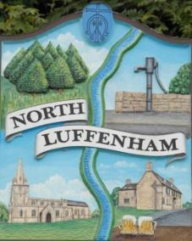
You are all invited to the Annual Parish Meeting on Monday 6th of March 2023 at 19.00 - NL Community Centre.
North Luffenham Parish Council

Agenda

- Chairman’s Report from Cllr Tim Smith.
- General Items for discussion/residents’ concerns
- Elections May 23
- Reports from village organisations and groups
- Any other business

Jadene Bale, Parish Clerk

