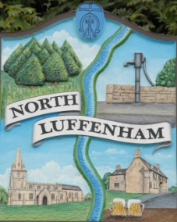
All Councillors are summoned to the Parish Council (Trust) Meeting immediately following the Parish Council Meeting on
North Luffenham Parish Council
Monday, 16th of January 2023 at 19:30 – NL Community Centre.

Agenda

09/23 Acceptance of apologies for absence
10/23 Declarations of Interest
11/23 To approve and sign Minutes:

Parish Council (Trust) meeting 16th of January 2022 [Document]

12/23 Correspondence

13/23 Finance Report

- To receive, consider and approve the Finance Report: [Document]
- To approve the following payments:
- M J Wyatt – Insurance for Allotments – £214.50
- Ionos - £6
- CM Services – 1st Instalment towards fencing - £3222

14/23 Field Gardens Report - Cllr Cade

Allotments:

- To receive an update on current availability of any vacant plots.

Woodland Walk:

- New fencing update

15/23 Oval Report - Cllr Cade

16/23 Date of next meeting: Monday 20th of March 2023
immediately following the NLPC meeting

Jadene Bale, Parish Clerk

