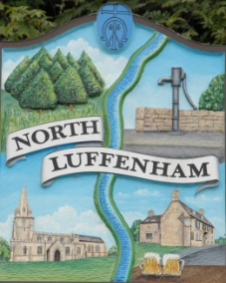
North Luffenham Parish Council
Minutes of the meeting of North Luffenham Parish Council held on Monday 16th January 2023 at 7.30pm at NL Community Centre

Present: Cllrs Smith, Cade, Barsby, Burrows and Marsh. C.Cllr Bool was also in attendance.

01/23 Acceptance of Apologies:
C.Cllr Waller, Cllr Gorse and Cllrs Sewell gave apologies. These apologies were accepted unanimously, having been proposed by Cllr Marsh and seconded by Cllr Burrows.
No apologies were received from Cllr Canham.

02/23 Declarations of Interest:
None

03/23 To approve and sign Minutes as follows:
It was proposed by Cllr Burrows and seconded by Cllr Marsh and unanimously agreed that the minutes of the meeting held on the 19th of December 2022 were correct and be approved and signed.

04/23 Correspondence
The Clerk advised allotment holders have contacted to advise they had no yet received their renewal letters. The Clerk assured the Trust that these would be sent out before the end of January.

05/23 Finance Report
A verbal report of the account balances was given to the Trust.

Payments:
• 1&1 Internet Ltd -£6
• 1&1 Internet Ltd - £21.72

Payments of the above expenditure were proposed by Cllr Burrows and seconded by Cllr Cade and unanimously agreed.

06/23 Field Gardens Report
It was proposed by Cllr Cade and seconded by Cllr Smith and unanimously agreed that the charges for the allotments stay the same as 22/23.

The council agreed unanimously (proposed by Cllr Barsby and seconded by Cllr Cade) that the work for the woodland walk fencing and gates be awarded to C M Services for their quote of £5370. Cllr Cade agreed to look into using the capital to fund the fencing and gate for the allotments with the Charity Commission.

07/23 Oval Report
Nothing to note.

08/23 Date of next meeting: Monday 20th of February 2023
immediately following the NLPC meeting

Jadene Bale, Clerk to NLPC

