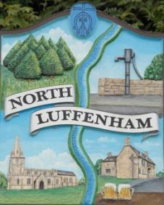
All Councillors are summoned to the Parish Council Meeting on Monday, 9th of May 2023 at 19:30 - NL Community Centre.
North Luffenham Parish Council

Agenda

75/23 Election of Chair

76/23 Election of Vice-chair

77/23 Co option

78/23 Apologies

79/23 Declaration of Interest

80/23 To review and confirm Committees and Working Groups for 2023/2024

Committees
- Planning Committee
- Staffing Committee

Working Groups
- St Georges Barracks Working Group
- Bonfire Night Working Group
- Finance Working Group
- Play area Working Group
- IT Working Group

Steering Groups
- Neighbourhood Plan Steering Group

81/23 Public Forum

82/23 To approve and sign Minutes as follows:

- Parish Council meeting 17th of April 2022 [Document]

83/23 Ward Report

84/23 Chairman’s Report

85/23 Correspondence

- Broken Bin in play area – inspected by RCC and recommended repair
- Green space maintenance – GreenBelt

86/23 Finance Report:
- To receive, consider and approve the Finance Report [Document]:
- To approve the following payments:
- Clerk’s Salary – £679.17 (£543.37 Net and 135.80 HMRC)
- Payroll – J Butlin - £15
- Zen – £42
- Direct Debit start up for Green Waste Bin – £50.00
- Zurich Insurance renewal - £668.88
- Hallmaster renewal - £238.80

87/23 Planning - Cllr Burrows

88/23 To receive and consider the report from the Community Centre Management Committee – Cllr Cade

89/23 To receive and consider the report from the CIL Group – Cllr Burrows

90/23 Speeding on Edith Weston Road

91/23 Update Policy – Standing Orders [Document]

92/23 North Luffenham Village Trust – Parish Council appointee

93/23 Elections - results

94/23 Date of next meeting: TBC

Jadene Bale, Parish Clerk

