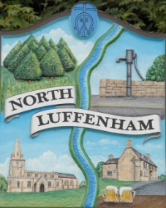
All Councillors are summoned to the Parish Council (Trust) Meeting immediately following the Parish Council Meeting on
North Luffenham Parish Council
Monday, 9th of May 2023 at 19:30 – NL Community Centre.

Agenda

33/23 Election of Chair
34/23 Election of Vice Chair
35/23 Acceptance of apologies for absence
36/23 Declarations of Interest
37/23 To review Committees and Working Groups for 2023/2024
- Oval/Field Working Group
38/23 To approve and sign Minutes:

Parish Council (Trust) meeting 17th of April 2023 [Document]

39/23 Correspondence

40/23 Finance Report

- To receive, consider and approve the Finance Report: [Document]
- To approve the following payments:
- Ionos - £6

41/23 Field Gardens Report - Cllr Cade

Allotments

Woodland Walk

42/23 Oval Report - Cllr Cade

43/23 Date of next meeting: TBC
immediately following the NLPC meeting

Jadene Bale, Parish Clerk

