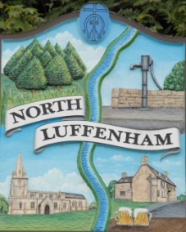
Minutes of the meeting of North Luffenham Parish Council (Trust) held on Tuesday 9th May 2023 at 7.30pm at NL Community Centre.
North Luffenham Parish Council

Present: Cllrs Smith (also C.Cllr), Cade, Spiegl and Burrows.

33/23 Election of Chair
It was unanimously agreed that Cllr Smith be elected as Chair for the council for 2023/2024.

34/23 Election of Vice Chair
It was unanimously agreed that Cllr Cade be elected as Vice-chair for the council for 2023/2024.

35/23 Acceptance of apologies for absence
Apologies were received and accepted from Cllr Gorse and C.Cllr Waller.

36/23 Declarations of Interest
Nil.

37/23 To review Committees and Working Groups for 2023/2024
It was proposed, seconded and unanimously agreed to postpone the allocation of members on each committee/working group until the June meeting whereby the attendance of all councillors is expected.

38/23 To approve and sign Minutes:

It was unanimously agreed that the minutes of the meeting held on the 17th of April 2023 were correct and be approved and signed.

39/23 Correspondence

Nil.

40/23 Finance Report

- To receive, consider and approve the Finance Report: [Document]
- To approve the following payments:
- Ionos - £6

Payments of the above expenditure were unanimously agreed.

41/23 Field Gardens Report - Cllr Cade
Allotments

2 allotments are vacant. 1 will be offered shortly to a resident, the other is yet to be offered due to its unlikely growing viability.

Woodland Walk
Shrubs and trees have been planted. The steps have been ‘disturbed’ and therefore repairs will need to be made.

42/23 Oval Report - Cllr Cade
Nil.

43/23 Date of next meeting:
Monday the 19th of June, immediately following the NLPC meeting.

Jadene Bale, Parish Clerk

