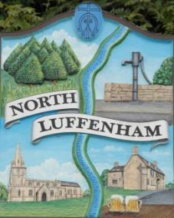
All Councillors are summoned to the Parish Council Meeting on Tuesday, 20th of June 2023 at 19:30 - NL Community Centre.
North Luffenham Parish Council

Agenda

100/23 Apologies

101/23 Declarations of Interest

102/23 Co-option

103/23 Public Forum

104/23 To approve and sign Minutes as follows:

- Parish Council meeting 9th of May 2023 [Document]
- EGM 7th of June 2023 [Document]

105/23 Ward Report

106/23 Chairman’s Report

107/23 To review and confirm Committees and Working Groups for 2023/2024

108/23 Correspondence

- Request for memorial tree.

- Broken Bin.

- Aerial on CC.

- Offer to purchase land.

- Damage to housing in village due to traffic.

- Internal Auditor report

109/23 Finance Report:
- To receive, consider and approve the Finance Report [Document]:
- To approve the following payments:
- Clerk’s Salary – £679.17 (£543.37 Net and 135.80 HMRC)
- Payroll – J Butlin - £15
- Zen – £42
- AGG -St Marys and St Johns School for PAT testing CC – £21.95
- LRALC – Internal Audit £220

110/23 Planning - Cllr Burrows

111/23 To receive and consider the report from the Community Centre Management Committee – Cllr Cade

112/23 To receive and consider the report from the CIL Group – Cllr Burrows

113/23 North Luffenham Village Trust Appointee

114/23 Date of next meeting: TBC

Jadene Bale, Parish Clerk

