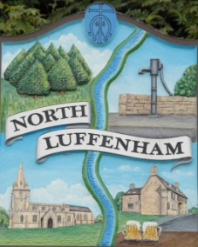
All Councillors are summoned to the Parish Council (Trust) Meeting immediately following the Parish Council Meeting on
North Luffenham Parish Council
Tuesday, 20th of June 2023 at 19:30 – NL Community Centre.

Agenda

44/23 Acceptance of apologies for absence
45/23 Declarations of Interest
46/23 To review Committees and Working Groups for 2023/2024
47/23 To approve and sign Minutes:
Parish Council (Trust) meeting 9th of May 2023 [Document]
48/23 Correspondence
- Bowls Club Lease
- Cricket Club Lease and reports of issues with nets.
49/23 Finance Report

- To receive, consider and approve the Finance Report: [Document]
- To approve the following payments:
- Ionos - £6
- Four Counties Ground Maintenance*– £315 x2 (Works completed in April and May)

*Two invoices have been received from Four Counties Ground Maintenance with incorrect billing details on. The clerk has asked for those details to be amended on those invoices, once amended the two payments can be made should approval be given.

50/23 Field Gardens Report - Cllr Cade

Allotments

Woodland Walk

51/23 Oval Report - Cllr Cade

52/23 Date of next meeting: TBC
immediately following the NLPC meeting

Jadene Bale, Parish Clerk

