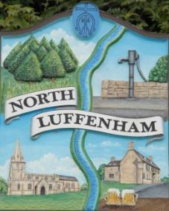
North Luffenham Parish Council All Councillors are summoned to the Parish Council Meeting on Monday, 17th of April 2023 at 19:30 - NL Community Centre.

All Councillors are summoned to the Parish Council Meeting on Wednesday 7th June at 19:30 - NL Community Centre.

Agenda

The public may attend the meeting but there will be no Public Forum

95/23 Apologies.

96/23 Declarations of interest.

97/23 Chairman’s Report.

98/23 Receive and discuss for approval the responses to the External Examiner’s requests for clarifications on North Luffenham Parish Council’s submitted Neighbourhood Plan.

99/23 Date of Next Meeting: Tuesday 20th June.

Tim Smith. Chair NLPC

