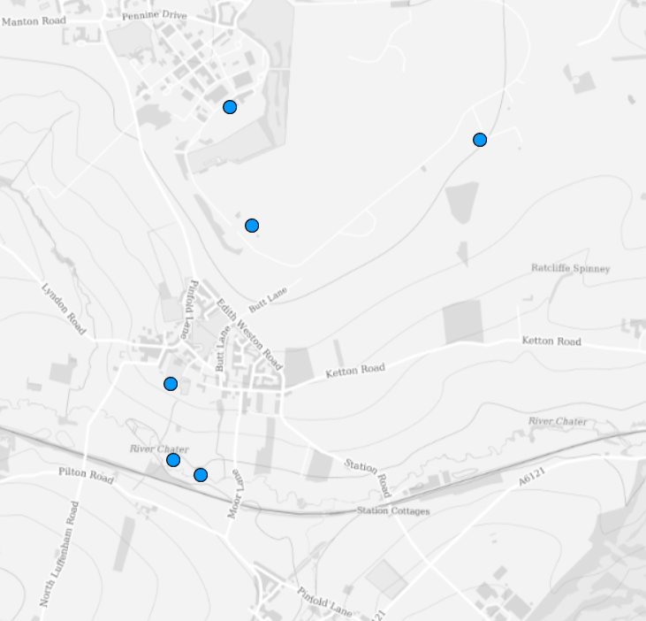
6
5
4
3
2
1

- Thor missile site
- The old airfield control (watch) tower at St. George’s Barracks.
- Bloodhound Missile Tactical Control Centre.
- The Ha-ha on the school playing field.
- The site of the lost village of Sculthorpe.
- The old fishponds adjacent to the River Chater.

