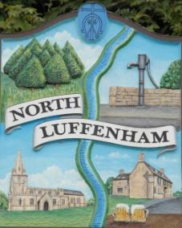
All Councillors are summoned to the Parish Council Meeting on Wednesday, 19th of July 2023 at 19:00 - NL Community Centre.
North Luffenham Parish Council

Agenda

115/23 Apologies

116/23 Declarations of Interest

117/23 Public Forum

118/23 To approve and sign Minutes as follows:

- Parish Council meeting 20th of June 2023 [Document]

119/23 Ward Report

120/23 Chairman’s Report

121/23 Correspondence

- Request for memorial tree.

- Broken Bin.

- Aerial on CC

- Offer to purchase land.

- Damage to housing in village due to traffic.

- Hanson – proposal to extend Ketton’s Grange Top Quarry

122/23 Finance Report:
- To receive, consider and approve the Finance Report [Document]:
- To approve the following payments:
- Clerk’s Salary – £679.17 (£543.37 Net and 135.80 HMRC)
- Clerk – Stationary - £63.63
- Payroll – J Butlin - £15
- Zen – £42
- St Marys and St Johns School - CC Bills – £1401.21
- LRALC – Internal Audit Travel Fees - £26.10
- LRALC – Playground Inspection Training - £60
- LRALC - Charitable Trusts Training - £50
- Cllr Barsby – Bunting - £71.30
- Cllr Cade – Fridge - £159*
- Cllr Cade – Hand towel dispenser - £16.85*
- Cllr Cade – Hand Towels (Sept 21) – £22.99*
- Cllr Cade – Hand Towels (May 22) – £26.33*
- Cllr Cade – Hand Towels (December 22) - £35.10*

*Subject to further information being supplied/audited.

123/23 Planning - Cllr Burrows

124/23 To receive and consider the report from the Community Centre Management Committee – Cllr Cade

125/23 To receive and consider the report from the CIL Group – Cllr Burrows

126/23 North Luffenham Village Trust Appointee

127/23 Date of next meeting: 16th August 2023

Jadene Bale, Parish Clerk

