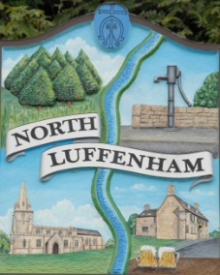
All Councillors are summoned to the Parish Council (Trust) Meeting immediately following the Parish Council Meeting on
North Luffenham Parish Council
Wednesday, 19th of July 2023 – NL Community Centre.

Agenda

53/23 Acceptance of apologies for absence
54/23 Declarations of Interest
55/23 To approve and sign Minutes:
Parish Council (Trust) meeting 20th of June 2023 [Document]
56/23 Correspondence
- Allotment Plots
57/23 Finance Report

- To receive, consider and approve the Finance Report: [Document]
- To approve the following payments:
- Ionos - £6
- Four Counties Ground Maintenance*– £315 (Works completed in June)
- Mow All - £480 (2x £240 Works completed in April and May)

58/23 Field Gardens Report - Cllr Cade

Allotments

Woodland Walk

59/23 Oval Report - Cllr Cade

60/23 Date of next meeting: 16th August 2023
immediately following the NLPC meeting

Jadene Bale, Parish Clerk

