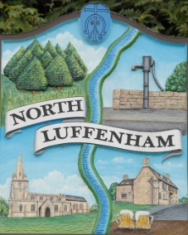
NORTH LUFFENHAM PARISH COUNCIL

DELARATION OF THE STATUS OF PUBLISHED ACCOUNTS FOR THE YEAR ENDING 31 MARCH 23

The statement of accounts that was published today for North Luffenham Parish Council are unaudited and may be subject to change.

The External Auditor is:
Moore
Rutland House
Minerva Business Park
Lynch Wood
Peterborough
PE26PZ

