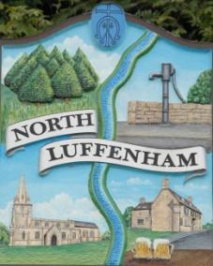
All Councillors are summoned to the Parish Council Meeting on Wednesday, 16th of August 2023 at 19:00 - NL Community Centre.
North Luffenham Parish Council

Agenda

128/23 Apologies

129/23 Declarations of Interest

130/23 Public Forum

131/23 To approve and sign Minutes as follows:

- Parish Council meeting 19th of July 2023 [Document]

132/23 Ward Report

133/23 Chairman’s Report

134/23 Correspondence

- Request for memorial tree.

- Broken Bin.

- Offer to purchase land.

- Damage to housing in village due to traffic.

- RCC Election charges

- Grass cutting

135/23 Finance Report:
- To receive, consider and approve the Finance Report [Document]:
- To approve the following payments:
- Clerk’s Salary – £679.17 (£543.37 Net and 135.80 HMRC)
- Payroll – J Butlin - £15
- Zen – £42

136/23 Planning - Cllr Burrows

137/23 To receive and consider the report from the Community Centre Management Committee – Cllr Cade

138/23 To receive and consider the report from the CIL Group – Cllr Burrows

139/23 Neighbourhood Plan

140/23 Date of next meeting: 16th August 2023

Jadene Bale, Parish Clerk

