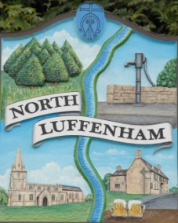
All Councillors are summoned to the Parish Council (Trust) Meeting immediately following the Parish Council Meeting on
North Luffenham Parish Council
Wednesday, 16th of August 2023 – NL Community Centre.

Agenda

61/23 Acceptance of apologies for absence
62/23 Declarations of Interest
63/23 To approve and sign Minutes:
Parish Council (Trust) meeting 19th of July 2023 [Document]
64/23 Correspondence
- Allotment Plots
- Lease agreement – For Bowls club and Cricket club
65/23 Finance Report

- To receive, consider and approve the Finance Report: [Document]
- To approve the following payments:
- Ionos - £6
- Four Counties Ground Maintenance– £315 (August)
- Mow All - £240 (June)

66/23 Field Gardens Report - Cllr Cade

Allotments

Woodland Walk

67/23 Oval Report - Cllr Cade

68/23 Date of next meeting: 16th August 2023
immediately following the NLPC meeting

Jadene Bale, Parish Clerk

