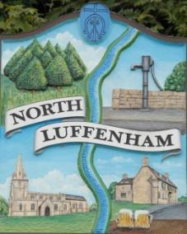
All Councillors are summoned to the Parish Council Meeting on Wednesday, 20th of September 2023 at 19:00 - NL Community Centre.
North Luffenham Parish Council

Agenda

141/23 Apologies

142/23 Declarations of Interest

143/23 Public Forum

145/23 To approve and sign Minutes as follows:

- Parish Council meeting 16th of August 2023 [Document]

146/23 Ward Report

147/23 Chairman’s Report

148/23 Correspondence

- Request for memorial tree.

- Broken Bin.

- Offer to purchase land.

- Damage to housing in village due to traffic.

- Grass cutting and Tidying up of village spaces

- Officers Mess Site

149/23 Finance Report:
- To receive, consider and approve the Finance Report [Document]:
- To approve the following payments:
- Clerk’s Salary – £679.17 (£543.37 Net and 135.80 HMRC)
- Payroll – J Butlin - £105 (Payroll from Sept 23 – March 24)
- Zen – £42
- RCC Election Results - £155.19

150/23 Planning - Cllr Burrows

151/23 To receive and consider the report from the Community Centre Management Committee – Cllr Cade

152/23 To receive and consider the report from the CIL Group – Cllr Burrows

153/23 Neighbourhood Plan

- Approval of Neighbourhood Plan for the referendum
- Approval of costs for the referendum

154/23 Date of next meeting: 18th October 2023

Jadene Bale, Parish Clerk

