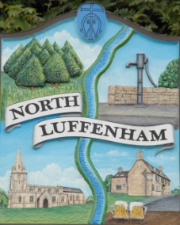
All Councillors are summoned to the Parish Council (Trust) Meeting immediately following the Parish Council Meeting on
North Luffenham Parish Council
Wednesday, 20th of September 2023 – NL Community Centre.

Agenda

69/23 Acceptance of apologies for absence
70/23 Declarations of Interest
71/23 To approve and sign Minutes:
Parish Council (Trust) meeting 16th of August 2023 [Document]
72/23 Correspondence
- Allotment Plots
- Lease agreement – For Bowls club and Cricket club
73/23 Finance Report

- To receive, consider and approve the Finance Report: [Document]
- To approve the following payments:
- Ionos - £6
- Four Counties Ground Maintenance– £315 (September)
- Mow All - £240 (August)

74/23 Field Gardens Report - Cllr Cade

Allotments

Woodland Walk

75/23 Oval Report - Cllr Cade

- Litter and dog waste bins

76/23 Date of next meeting: 18 October 2023
immediately following the NLPC meeting

Jadene Bale, Parish Clerk

