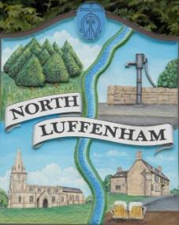
North Luffenham Parish Council
There will be a meeting of the Community Centre Committee in the Community Centre on 11th September 2023 at 7.00pm.

Agenda
23/23 Apologies
24/23 Declarations of Interest
25/23 Approval of the minutes of the 17-07-23
26/23 Matters Arising:
- Electric Meter
- Charges for hire added to Hallmaster
- Charge for use of the toilets
- Improving the appearance of the CC
27/23 Promotion/advertising of CC
28/23 Finance Report.
29/23 Liaison with St Mary & St. John CEVA Primary School
30/23 Date of next meeting

Charles Cade
05-09-23
Chair CCC.

