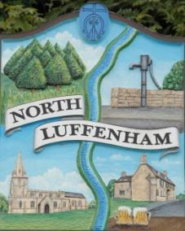
All Councillors are summoned to the Parish Council Meeting on Wednesday, 18th of October 2023 at 19:00 - NL Community Centre.
North Luffenham Parish Council

Agenda

155/23 Apologies

156/23 Declarations of Interest

157/23 Public Forum

158/23 To approve and sign Minutes as follows:

- Parish Council meeting 20th of September 2023 [Document]

159/23 Ward Report

160/23 Chairman’s Report

161/23 Correspondence

- Request for memorial tree.

- Broken Bin.

- Damage to housing in village due to traffic.

- Grass cutting and tidying up of village spaces.

- AGAR – Moore External Auditor

- Local Plan Meeting – 18 October 2023 at 7pm at the Council Chambers at RCC.

- LRALC AGM – Invites to join £10 per delegate to cover food costs.

- Support requested following two near fatal crashes – Mr Kingston/Highways

- Broken Bridge – Highways

162/23 Finance Report:
- To receive, consider and approve the Finance Report [Document]:
- To approve the following payments:
- Clerk’s Salary – £679.17 (£543.37 Net and 135.80 HMRC)
- Zen – £42
- Moores External Auditor – £252
- Spiel Press - £133.15

163/23 Planning - Cllr Burrows

164/23 To receive and consider the report from the Community Centre Management Committee – Cllr Cade

165/23 To receive and consider the report from the CIL Group – Cllr Burrows

166/23 Neighbourhood Plan

167/23 Community Service Award

168/23 Village Website

169/23 North Luffenham Youth Parish Council

170/23 Date of next meeting: 15th November 2023

Jadene Bale, Parish Clerk

